Annette Bazan
L05 AI 900
ITAI 2372
Reflective Journal: Lab 05 Exploring Generative AI in Azure AI foundry Portal
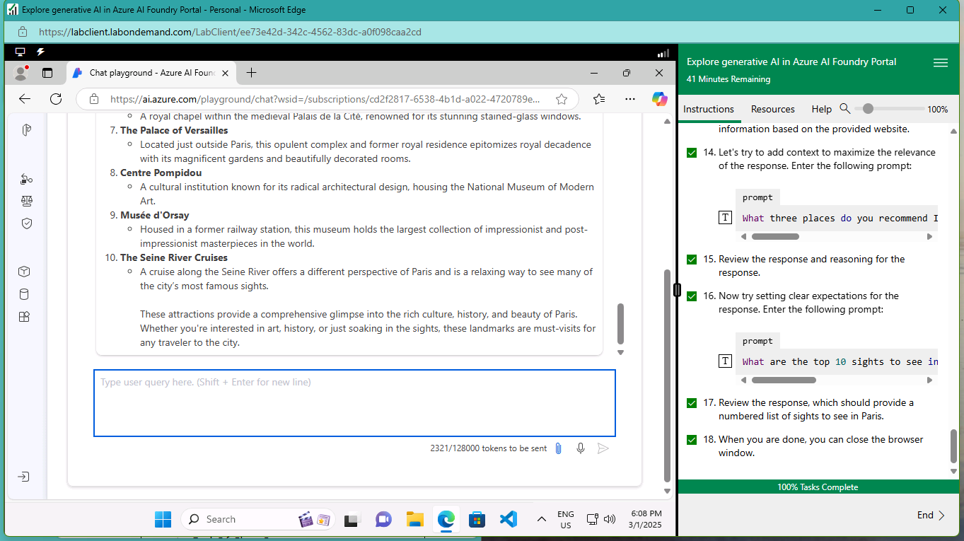
This lab is our fifth and final lab that allowed us to explore the capabilities of generative AI using the Azure AI Foundry Portal. The lab was able to simulate a crafted contextual relevant prompt and review the AI-generated responses. The scenario centered around recommending tourist attractions in Paris, which provided a real-world use case for testing prompt refinement and evaluating AI output.
This lab allowed me to discover how to add context like specifying the number of items, the theme or perspective which significantly enhances the quality of AI-generated outputs. It taught me how to effectively design prompts to get more accurate and useful responses from the AI. Allowing me to gain experience in analyzing responses not just for correctness but also for clarity completeness and relevance to the original query.
The challenges I faced were minor in my opinion and that was getting the generative AI working, it was a hardware issue I found that took me a few days to configure and be able to finish up the lab. Navigating the interface and managing prompt input/output withing the chat playground also required some trial and error. These small challenges were valuable in the insight I gained in working through the lab. There were clear expectations within the prompts to help guide the AI toward more targeted results. Iterative testing which means adjusting a prompt and comparing different responses to master prompt engineering. After everything this lab reaffirmed how generative AI can assist in real-world scenarios such as education, customer service and travel planning.
In conclusion and overall, this lab was another valuable experience in hands on and understanding the practical application of generative AI within the Azure simulations. It helped reinforce best practices for crafting prompts and highlighted how AI can serve as a powerful tool when used thoughtfully and strategically,

